Multiple-choice section

|  |  |  |  |  |  |  |  |  |
| --- | --- | --- | --- | --- | --- | --- | --- | --- |
| Question | 1 | 2 | 3 | 4 | 5 | 6 | 7 | 8 |
| Answer | B | C | C | A | B | A | A | B |

Question 1 [8.1]

**B**

You can walk around the school and observe the number in each class

Question 2 [8.2]

**C**

0, 1, 1, 2, 3, 4, 6, 7

Mean =  = 3

Median =  = 2.5

Question 3 [8.3]

**C**

 = 27

Question 4 [8.5]

**A**

9 balls in total, 3 of which are red: 

Question 5 [8.5]

**B**

Five 4’s have been rolled out of a total of 30 rolls.



Question 6 [8.5]

**A**

multiples of 4: 4, 8, 12, 16, 20, 24, 28

multiples of 6: 6, 12, 18, 24, 30

12 and 24 are the only successful outcomes: 

Question 7 [8.7]

**A**

There are 25 outcomes possible, only one of which is the one required, so the answer is .

Question 8 [8.7]

**B**

Pr(B and odd) = 

Multiple-choice total marks: 8

Short answer section

Question 9 3 marks [8.1] [8.5]

**(a)** An event for which the probability is 0 is said to be *impossible*.

**(b)** The number of goals scored by each team in one round of a netball competition is an example of *discrete data*.

**(c)** If a statistical graph is not skewed it is said to be *symmetrical*.

Question 10 2 marks [8.5]

(Other words and phrases are possible.)

impossible  no way    Buckley’s  unlikely   perhaps   possible  fifty–fifty  
even chance probable most likely  almost certain   certain

Question 11 5 marks [8.2]

|  |  |  |  |  |  |  |  |  |
| --- | --- | --- | --- | --- | --- | --- | --- | --- |
| A | *x* | *f* | B | *x* | *f* | C | *x* | *f* |
|  | 30  31  32  33  34 | 15  16  6  3  1 |  | 15  16  17  18  19  20 | 2  2  0  5  9  6 |  | 48  49  50  51  52  53 | 4  6  15  15  6  4 |

**(a)** mean = median for C since the distribution is symmetrical.

**(b)** B and C have the same range:

B: Range = 20 – 15 = 5

C: Range = 53 – 48 = 5

For A: Range = 34 – 30 = 4

**(c)** ‘A’ has a positive skew (tail to the right).

|  |  |  |
| --- | --- | --- |
| *x* | *f* | *x* × *f* |
| 30  31  32  33  34 | 15  16  6  3  1 | 450  496  192  99  34 |
| Total | 41 | 1271 |

mean =  = 31

median: 21st datum = 31

Question 12 7 marks [8.3]

**(a)**

|  |  |  |  |
| --- | --- | --- | --- |
| Distance (m) | Frequency | Midpoint | *xf* |
| 0−<10 | 3 | 5 | 15 |
| 10−<20 | 15 | 15 | 225 |
| 20−<30 | 20 | 25 | 500 |
| 30−<40 | 11 | 35 | 385 |
| 40−<50 | 2 | 45 | 90 |
|  | Σ*f* = 51 |  | Σ*xf* = 1215 |

mean =  = 23.8

**(b)**

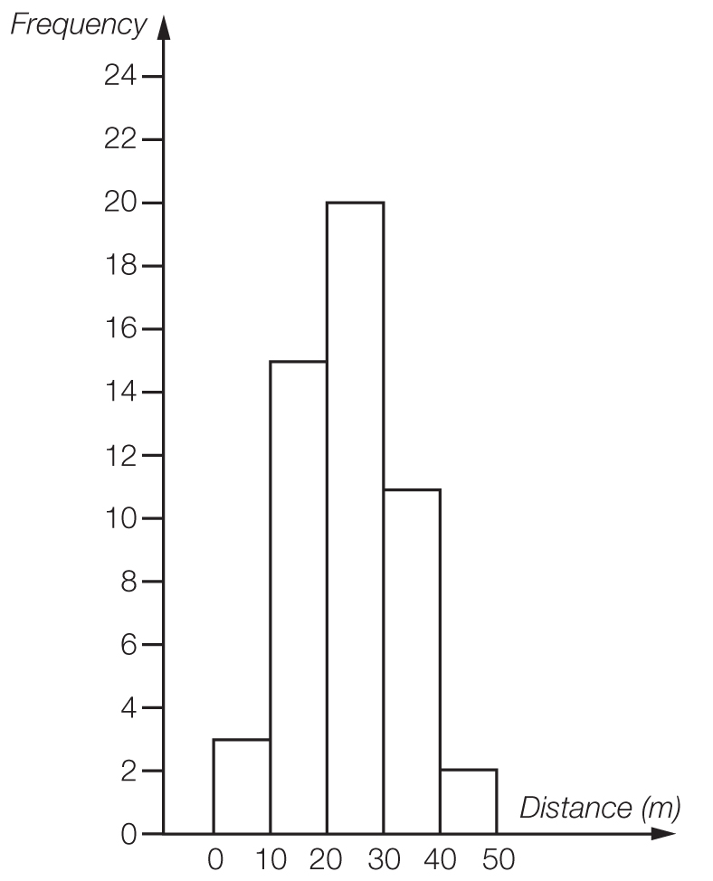

The large number of values in the middle band makes this relatively symmetrical.

Question 13 2 marks [8.5]

**(a)** Pr(Steven wins) =  = 40%

**(b)**  × 8 = 4.8

Nikki would expect to win 5 games.

Question 14 3 marks [8.5]

**(a)** Pr(neither red nor pink) =  = 

**(b)**  × 5 ≈ 0.95

1 lolly would be expected to be pink or brown.

Question 15 10 marks [8.6]

**(a)** **(i)** *A* and *B* are mutually exclusive.

**(ii)** *A* and *C* are not mutually exclusive.

**(iii)** *A* and *D* are not mutually exclusive.

**(b) (i)** Pr(*B* and *D*) = Pr(3, 5, 7, 11, 13, 17, 19) = 

**(ii)** Pr(*C* or *D*) =  = 

**(iii)** Pr(*A* and *B*) = 0

**(iv)** Pr(*B* only) =  = 

Question 16 8 marks [8.7]

(a)

|  |  |  |  |  |  |  |  |  |  |
| --- | --- | --- | --- | --- | --- | --- | --- | --- | --- |
|  | R1 | R2 | R3 | R4 | Y1 | Y2 | B1 | B2 | B3 |
| R1 |  | RR | RR | RR | RY | RY | RB | RB | RB |
| R2 | RR |  | RR | RR | RY | RY | RB | RB | RB |
| R3 | RR | RR |  | RR | RY | RY | RB | RB | RB |
| R4 | RR | RR | RR |  | RY | RY | RB | RB | RB |
| Y1 | YR | YR | YR | YR |  | YY | YB | YB | YB |
| Y2 | YR | YR | YR | YR | YY |  | YB | YB | YB |
| B1 | BR | BR | BR | BR | BY | BY |  | BB | BB |
| B2 | BR | BR | BR | BR | BY | BY | BB |  | BB |
| B3 | BR | BR | BR | BR | BY | BY | BB | BB |  |

**(b)** Pr(RR) = 

**(c)** Pr(RR, YY or BB) = 

**(d)** Pr(neither blue) = 

**(e)** Pr(BY or YB) = 

Question 17 5 marks [8.3]

**(a)** This data set has positive skew since the mean has been pulled to the right.

**(b)** To give a mean of 39 from 16 scores, the total must be 624.

A sample answer: put 27 and 28 in the middle two positions to give a median of 27.5. There must be more 21s than any other score.

e.g. 21, 21, 21, 25, 26, 26, 27, 27, 28, 46, 50, 56, 56, 59, 65, 70

Short answer total marks: 42

Extended answer section

Question 18 15 marks [8.4]

**(a)** NSW: mean =  = 165.9 cm

Victoria: mean =  = 168.9 cm

**(b)**

|  |  |  |
| --- | --- | --- |
| NSW Year 9 students |  | Victoria Year 9 students |
| 3 | 14 | 6 |
| 9 8 8 7 6 5 2 0 | 15 | 5 |
| 8 7 5 5 4 4 3 2 1 0 | 16 | 0 0 0 2 3 3 4 5 5 7 7 8 9 9 |
| 9 7 7 7 4 4 0 0 | 17 | 0 0 0 1 2 5 6 7 7 |
| ­­­­7 4 0 | 18 | 0 0 0 3 3 |

**(c)** NSW: median = 164.5 cm and range = 187 – 143 = 44 cm

Victoria: median = 169 cm and range = 183 – 146 = 37 cm

**(d)** Although the mean and median are close for the two different states the range of heights is different. The shortest student comes from NSW as does the tallest.

**(e)** Estimated mean:  = 167.4 cm

Estimated median: = 167 cm

Range of sample of 60: 187 – 143 = 44 cm so population range is almost certain to be higher, say 70 cm, unless the tallest and shortest Year 9 students in both states just happened to be in this sample. It is assumed that the samples are random and hence mean and median of samples is the best predictor of population averages. Equal numbers of Year 9 students in each state are also assumed, which is unlikely. The limitation is that this will only predict population statistics for the same time of year as the data was gathered as a portion of Year 9 students will grow throughout the year.

Question 19 8 marks [8.6]

(a)

|  |  |  |  |
| --- | --- | --- | --- |
|  | Prepaid mobile | No Prepaid mobile |  |
| Overseas holiday | 3 | 2 | 5 |
| No overseas holiday | 15 | 6 | 21 |
|  | 18 | 8 | 26 |

(b)

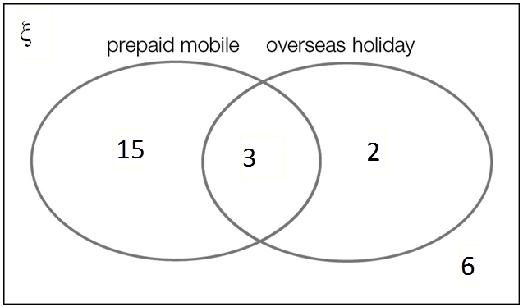

**(c)** **(i)** Pr(prepaid mobile phone) =  = 

**(ii)** Pr(prepaid mobile phone and overseas holiday) = 

**(iii)** Pr(no overseas holiday) = 

**(d)** Pr(prepaid mobile knowing overseas holiday) = 

Question 20 14 marks [8.5]

**(a)** mean =  ≈ 36.5 runs

0, 0, 0, 0, 0, 0, 0, 1, 2, 2, 3, 3, 11, 11, 13 | 17, 18, 19, 32, 32, 44, 44, 49, 69, 73, 81, 99, 141, 148, 182

median = 15 runs

range = 182 – 0 = 182 runs

**(b)** Pr(score is under 10) =  × 100% = 40%

**(c)** Without scores under 10:

mean =  ≈ 60.2 runs

**(d)** **(i)** Pr(at least 50) =  × 100% ≈ 23%

**(ii)** Pr(at least 100) =  × 100% = 10%

**(e)** Pr(100 once 50 is reached) =  × 100% ≈ 43%

Extended answer total marks: 37

TOTAL test marks: 87